Name: ___________________________
HISTORICAL GEOLOGY (GEY112)
PRE-LAB
“Sedimentary Facies and Environments: Introduction to Siliciclastic Rocks”

Define:
- Paleoenvironment – and environment that dominates a given area

- Lithofacies – record of the environment showing physical and organic characteristics

- Sedimentary Structure – how sediments were deposited given physical features such as ripples, mud cracks, etc…

- Walther’s Law – facies that were adjacent to one another can shift to overlie those that they were once adjacent.

Questions:
  - List and define three characteristics of sedimentary particles:

a) Size
b) sorted
c) rounded

  - List and define the three types of Bedding:

a) cross – deltas, streams, asymmetrical
b) graded – coarse layered down first with little material
c) plane – parallel layers of sediment

  - List and define three “other” sedimentary structures that may be found associated with sedimentary rock.

Bioturbation, Rain drop, Soft Sediment Deformation

  - You find a red sandstone, the sandstone contains a few plant fossils and contains thin layers of black shale. What siliciclastic sedimentary environment is most likely indicated by these layers of sandstone and shale?

A stagnant body of water near the coast of an ocean or an inland sea.

  - What is meant by Transgression? Regression?

Transgression is when the sea level rises, due to glacial melt and other factors caused by global warming, causing water to permanently flood the land.

Regression is where sea levels drop, due to global cooling and forming of glaciers, exposing the sea floor.

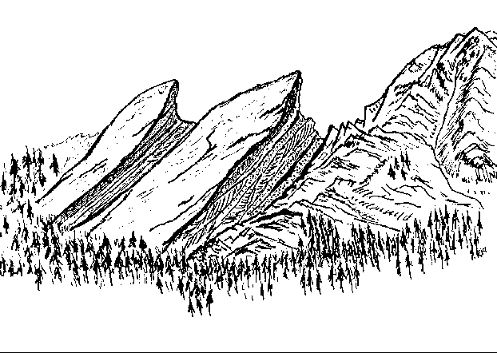
Fountain Formation, Boulder Colorado

Siliciclastic Sedimentary
Rocks Laboratory

Introduction:
Siliciclastic rocks are essentially earth materials that have been derived through weathering of rocks. These consist of mainly the durable silicate minerals such as quartz. These are often accompanied by minerals such as Calcite, Hematite, and Limonite.

In unusual circumstance un-weathered material may be a component of these rock types such as: Mica and Feldspar. Under normal conditions these minerals weather quickly to form CLAY. If Mica and Feldspar are present this means that the material was fairly close to the original “source” rock, or rock that these minerals were derived from.

Procedure:
I. Examine the specimens given to you by your instructor. Determine the rock type and origin of the sediment for each. Ultimately you will determine how these sediments collected also known as the “Depositional Environment.”

Pay particular attention to:
- Particle size: Gravel, Sand, Silt, clay….
- Particle Rounding: Are the particles round or angular?
- Sorting: Ratio of large to small particles.
- Clay content: This may be determined by breathing on the rock. If an “earthy” smell is detected then clay is present.
- Sedimentary structures: Mudcracks, ripple marks, cross-bedding, burrows, etc…
- Color
- Mineral Composition:
    - Feldspar – if present this indicates that the source is close to the basin of deposition.
    - Hematite – Rust red color. Iron oxide mineral.
    - Limonite – Yellow to yellow brown color. Iron oxide mineral.
    - Calcite – cementing agent.
    - Quartz – very resistant to erosion, most common.
II. DUE
      - PRE LAB for Siliciclastic Rocks and Sedimentary Environments
      - Siliciclastic Rocks Worksheet/Data
      - POST LAB (last page of lab) Determine the sequence (vertical sequence) for transgressive and regressive events based on the diagrams included

Siliciclastic Sedimentary Rocks
Paleo-environments

Sedimentary Structures that may occur, includes fossils.
Origin: Possible Environment of Deposition
Rock Type
Sediment Type: Before Lithification/Diagenesis

Gravel - Poorly sorted large rounded pebbles predominate, sand, silt, and clay are present. Rounding indicates distant source.
High Energy environments: Streams, rivers, alluvial fan deposits, submarine canyon, and Glacial.
Massive bedding, cross bedding can occur although this may be difficult to determine. Channel “fill” common.
Conglomerate

High Energy environments: Alluvial fan deposits, Glacial deposit, landslide deposits on land and underwater.
Gravel – Poorly sorted angular pebbles predominate, sand, silt, and clay may be present. Lack of rounding indicates proximity to source.
Massive bedding, cross bedding can occur although this may be difficult to determine.

Breccia

Moderate Energy environments: Streams, tidal flat, delta, shallow marine, estuary, dune, rivers, alluvial fan deposits, and submarine canyon.
Massive bedding, cross bedding, burrows, graded bedding, ripple marks, flutes, tracks.
Sand predominates, silt and clay may be present. Grains can be rounded to angular.
Sandstone

Silt predominates, clay may be present. Grains can be rounded to angular. Although this is very hard to determine in hand samples.
Moderate Energy environments: Streams, tidal flat, estuary, dune, delta, shallow marine, rivers, alluvial fan deposits, and submarine canyon.
Massive bedding, cross bedding, burrows, graded bedding, ripple marks, flutes, tracks, mudcracks.
Siltstone

Clay predominates, some silt may be present. Shale will contain distinct laminated layers. Mudstone will not contain distinct layers.
Low Energy environments: Streams, tidal flat, delta, shallow marine, rivers, alluvial fan deposits. Lagoon, Lake, abyssal plain, playa lake,
Massive bedding, burrows, flutes, tracks, mudcracks.
Shale/
Mudstone

Name:____________________________
Siliciclastic Rocks Worksheet/Data
Sample #
Environment of Deposition? (Several possibilities may exist for each)
Sedimentary Structure(s)? Includes fossils.
Description: (fossils, color, grain size & shape)
Rock Name(s)

Name:____________________________
Siliciclastic Rocks Worksheet/Data
Sample #
Environment of Deposition? (Several possibilities may exist for each, p. 10-12)
Sedimentary Structure(s)? Includes fossils.
Description: (fossils, color, grain size & shape)
Rock Name(s)

NAME: ________________________________
POST LAB for Siliciclastic Rocks
Transgression - Regression
GEY 112 - Historical Geology
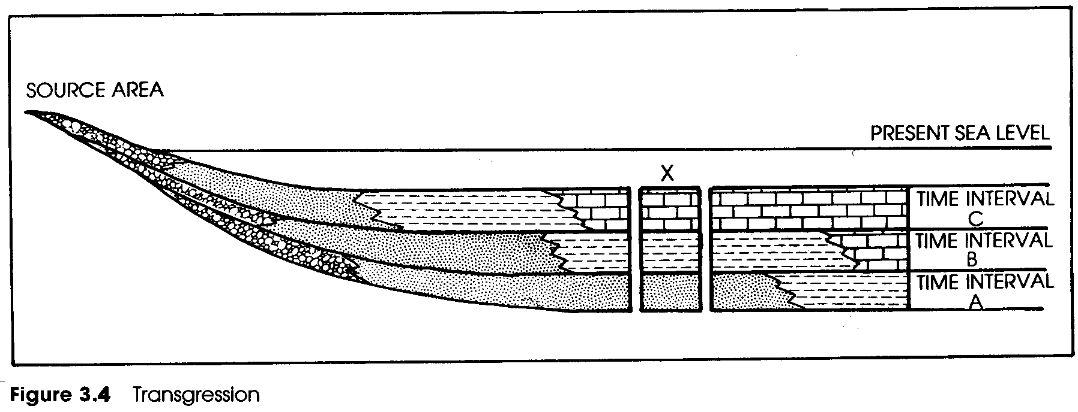
Diagram modified from Peterson & Rigby 1994.
DIAGRAM #1
Shale
Limestone
Sandstone
Conglomerate
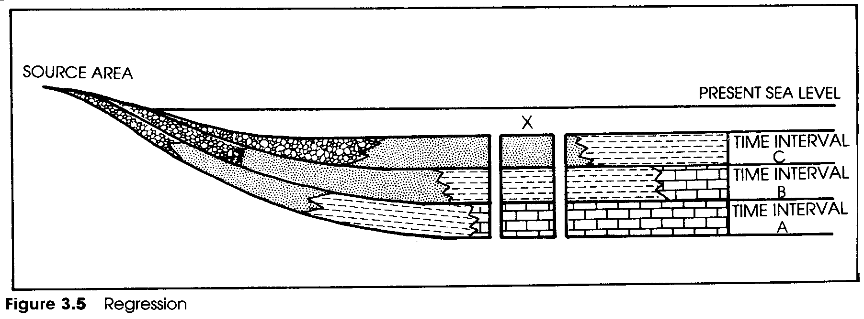
Diagram modified from Peterson & Rigby 1994.
DIAGRAM #2

NOTE: “X” indicates the vertical section derived from each sequence. When a geologist has a vertical section of layers, like those indicated by “X,” to work with and interpret sea level rise and fall this is known as “Walthers Law.”

Please determine the following:

1.The vertical sedimentary sequence of DIAGRAM #1 at “X.” What does the vertical and lateral distribution of sediments indicate about sea level?

The sea level is rising which is called transgression. This is evident by the layering of limestone on top of shale which is on top of sandstone. This is caused by the water slowly creeping inland with wave action helping to sort the layers.

2.The vertical sedimentary sequence of DIAGRAM #2 at “X.” What does the vertical and lateral distribution of sediments indicate about sea level?

The sea level is falling which is called regression. This is evident by the layering of sandstone on top of shale which is on top of limestone. This is caused by the water slowly fading from the land with wave action helping to sort the layering.

